Appendix
eTable1 The patient satisfaction over five aspects for each hospital
eTable2 The change of hospital performance category over five aspects
eTable3 The hospital performance category after adjustment over five aspects
eFigure1 The change of hospital rank over five aspects

eTable1 The patient satisfaction on five aspects for each hospital
Hospital code | Patient number | Administrative process |  | Hospital environment |  | Medical care |  | Symptom management |  | Overall satisfaction
Hospital code | Patient number | Score | Rate,% | Score | Rate,% | Score | Rate,% | Score | Rate,% | Score | Rate,%
A | 158 | 4.75 | 84.81 | 4.69 | 89.24 | 4.79 | 93.04 | 4.65 | 66.20 | 4.75 | 82.91
B | 168 | 4.87 | 94.05 | 4.84 | 97.02 | 4.99 | 100.00 | 4.88 | 91.67 | 4.96 | 98.21
C | 142 | 4.69 | 80.99 | 4.60 | 85.92 | 4.85 | 92.96 | 4.55 | 67.12 | 4.80 | 85.92
D | 148 | 4.58 | 67.57 | 4.40 | 62.16 | 4.68 | 72.30 | 4.60 | 65.91 | 4.61 | 67.57
E | 160 | 4.78 | 91.88 | 4.71 | 90.63 | 4.77 | 93.75 | 4.62 | 72.00 | 4.74 | 83.75
F | 157 | 4.72 | 84.08 | 4.59 | 79.62 | 4.84 | 92.36 | 4.66 | 72.41 | 4.75 | 80.25
G | 164 | 4.68 | 80.49 | 4.61 | 85.98 | 4.87 | 94.51 | 4.55 | 67.69 | 4.83 | 89.02
H | 149 | 4.56 | 85.23 | 4.77 | 94.63 | 4.96 | 97.99 | 4.91 | 92.22 | 4.91 | 96.64
I | 158 | 4.75 | 84.18 | 4.74 | 85.44 | 4.88 | 91.14 | 4.72 | 77.27 | 4.83 | 87.34
J | 149 | 4.47 | 64.43 | 4.31 | 57.72 | 4.64 | 75.84 | 4.47 | 55.41 | 4.55 | 63.09
K | 153 | 4.82 | 94.12 | 4.75 | 90.85 | 4.86 | 96.08 | 4.96 | 97.5 | 4.86 | 92.81
L | 149 | 4.79 | 89.26 | 4.77 | 93.29 | 4.91 | 96.64 | 4.86 | 88.31 | 4.89 | 93.96
M | 149 | 4.58 | 71.14 | 4.50 | 65.77 | 4.66 | 80.54 | 4.68 | 77.14 | 4.63 | 72.48
N | 168 | 4.71 | 85.12 | 4.60 | 79.17 | 4.72 | 86.31 | 4.63 | 72.84 | 4.76 | 87.50
O | 175 | 4.76 | 86.29 | 4.74 | 92.00 | 4.9 | 94.29 | 4.80 | 84.04 | 4.83 | 88.57
P | 149 | 4.56 | 74.50 | 4.46 | 75.17 | 4.75 | 87.25 | 4.51 | 60.23 | 4.69 | 75.17
Q | 175 | 4.69 | 86.86 | 4.61 | 86.86 | 4.81 | 90.29 | 4.68 | 72.41 | 4.77 | 85.71
R | 151 | 4.87 | 95.36 | 4.73 | 96.69 | 4.85 | 94.7 | 4.67 | 77.27 | 4.76 | 87.42
S | 144 | 4.88 | 95.83 | 4.83 | 97.22 | 4.86 | 97.22 | 4.74 | 87.5 | 4.91 | 97.22
T | 168 | 4.68 | 82.14 | 4.66 | 86.90 | 4.87 | 94.05 | 4.77 | 78.45 | 4.86 | 89.88
U | 145 | 4.48 | 69.66 | 4.56 | 77.24 | 4.79 | 86.21 | 4.61 | 67.33 | 4.71 | 80.00
V | 162 | 4.56 | 75.31 | 4.62 | 82.72 | 4.83 | 93.21 | 4.69 | 76.19 | 4.71 | 82.10
W | 161 | 4.50 | 68.32 | 4.31 | 71.43 | 4.78 | 94.41 | 4.54 | 61.29 | 4.63 | 73.29
X | 146 | 4.73 | 87.67 | 4.73 | 93.84 | 4.91 | 97.26 | 4.76 | 82.72 | 4.87 | 93.84
Y | 192 | 4.43 | 64.58 | 4.47 | 72.40 | 4.5 | 73.96 | 4.50 | 62.5 | 4.48 | 61.46
Z | 186 | 4.66 | 81.18 | 4.71 | 90.32 | 4.85 | 95.16 | 4.67 | 80.23 | 4.80 | 88.71
XA | 148 | 4.41 | 70.27 | 4.42 | 79.05 | 4.77 | 85.81 | 4.57 | 68.06 | 4.73 | 80.41
NA | 171 | 4.61 | 78.95 | 4.62 | 81.29 | 4.78 | 84.80 | 4.54 | 64.86 | 4.77 | 80.12
NB | 197 | 4.69 | 80.71 | 4.67 | 83.76 | 4.83 | 94.42 | 4.62 | 74.67 | 4.80 | 85.79
NC | 205 | 4.85 | 93.66 | 4.86 | 96.10 | 4.94 | 97.56 | 4.82 | 86.02 | 4.91 | 95.12

eTable2 The change of hospital performance category over five aspects
- Process management
Before case-mix adjustment | After case-mix adjustment
Before case-mix adjustment | Better | Average | Worse
Better | 6 | 0 | 0
Average | 0 | 15 | 0
Worse | 0 | 0 | 9
- Hospital environment
Before case-mix adjustment | After case-mix adjustment
Before case-mix adjustment | Better | Average | Worse
Better | 8 | 0 | 0
Average | 0 | 12 | 0
Worse | 0 | 0 | 10
- Medical care
Before case-mix adjustment | After case-mix adjustment
Before case-mix adjustment | Better | Average | Worse
Better | 4 | 0 | 0
Average | 0 | 17 | 0
Worse | 0 | 0 | 9
- Symptom management
Before case-mix adjustment | After case-mix adjustment
Before case-mix adjustment | Better | Average |  | Worse
Better | 3 |  | 2 | 0
Average | 0 |  | 22 | 0
Worse | 0 |  | 0 | 3
- Overall satisfaction
Before case-mix adjustment | After case-mix adjustment
Before case-mix adjustment | Better | Average | Worse
Better | 6 | 1 | 0
Average | 0 | 12 | 1
Worse | 0 | 1 | 9
Note: Better means confidence interval of satisfaction variation is over 0; average means confidence interval of satisfaction variation contains 0; worse means confidence interval of satisfaction variation is below 0.

eTable3 The hospital performance category after adjustment over five aspects
Hospital code | Administrative process | Hospital environment | Medical care | Symptom management | Overall satisfaction
A | average | average | average | average | worse
B | better | better | better | better | better
C | average | average | average | average | average
D | worse | worse | worse | average | worse
E | better | average | average | average | average
F | average | worse | average | average | worse
G | average | average | average | average | average
H | average | better | better | better | better
I | average | average | average | average | average
J | worse | worse | worse | worse | worse
K | better | average | average | better | average
L | average | better | average | average | better
M | worse | worse | worse | average | worse
N | average | worse | worse | average | average
O | average | better | average | average | average
P | worse | worse | worse | worse | worse
Q | average | average | average | average | average
R | better | better | average | average | average
S | better | better | average | average | better
T | average | average | average | average | average
U | worse | worse | worse | average | average
V | worse | average | average | average | average
W | worse | worse | average | worse | worse
X | average | better | better | average | better
Y | worse | worse | worse | average | worse
Z | average | average | average | average | average
XA | worse | worse | worse | average | worse
NA | average | average | worse | average | worse
NB | average | average | average | average | average
NC | better | better | better | average | better
Note: Better means confidence interval of satisfaction variation is over 0; average means confidence interval of satisfaction variation contains 0; worse means confidence interval of satisfaction variation is below 0.

eFigure1 The change of hospital rank over five aspects
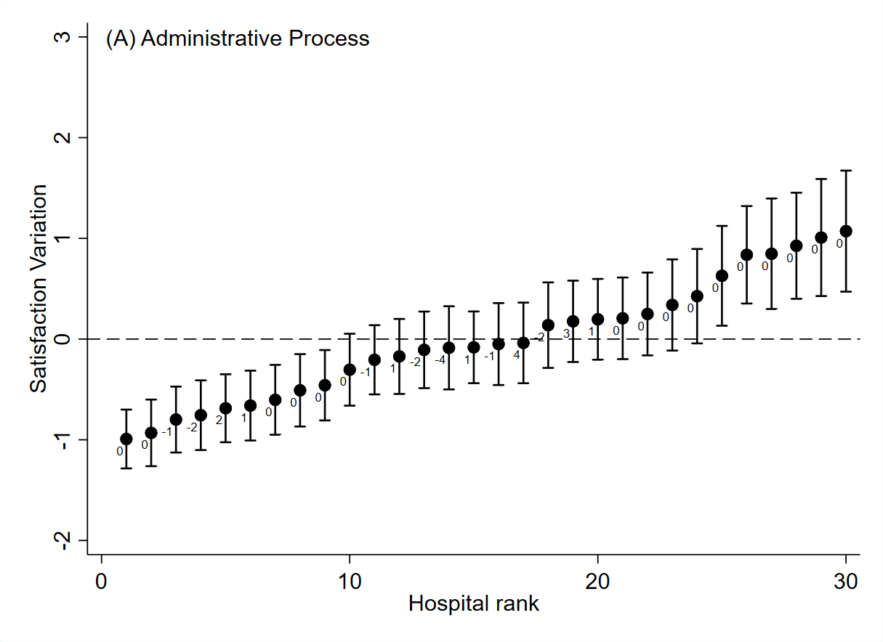
Note: The value label of pot is the hospital rank change after adjustment. The change range of hospital rank is [-4,4].
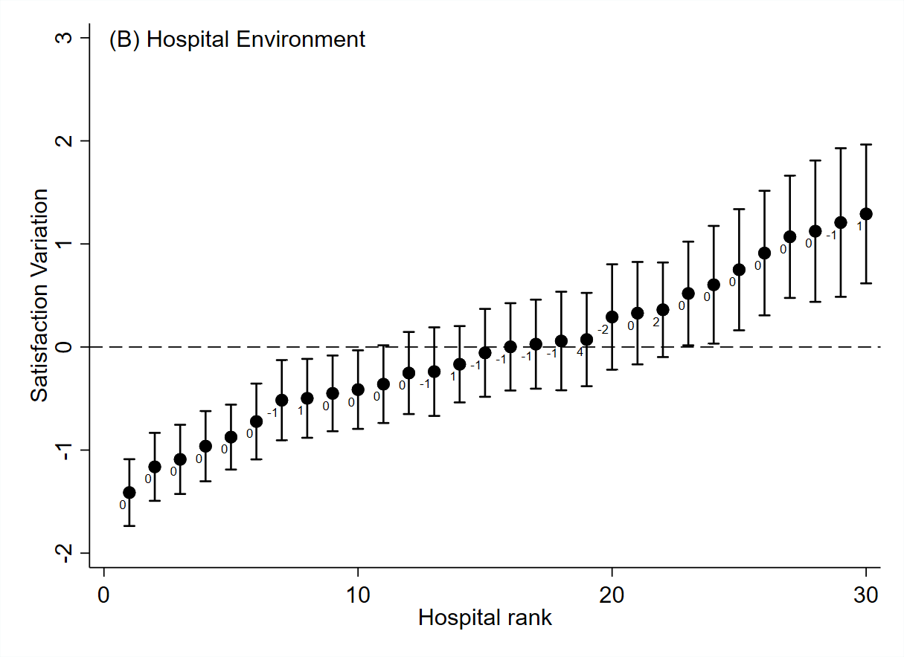
Note: The value label of pot is the hospital rank change after adjustment. The change range of hospital rank is[-2,4]
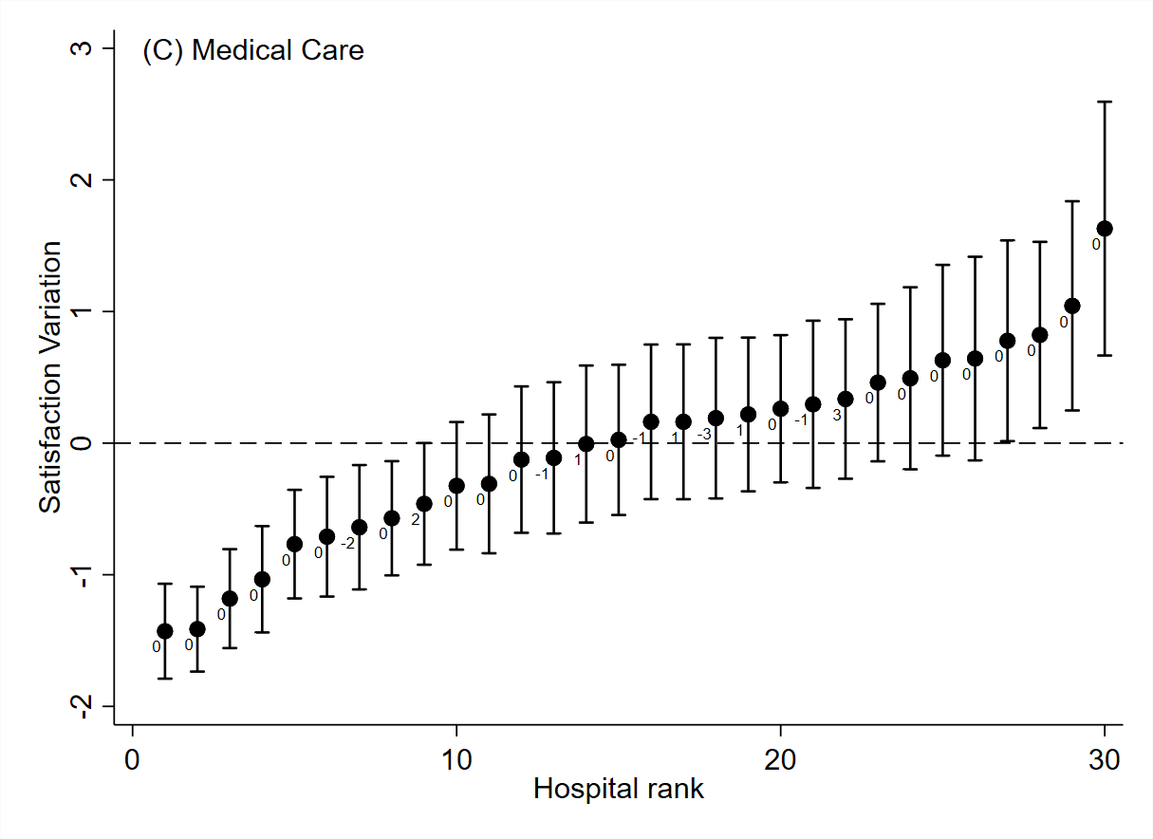
Note: The value label of pot is the hospital rank change after adjustment. The change range of hospital rank is [-3,3]
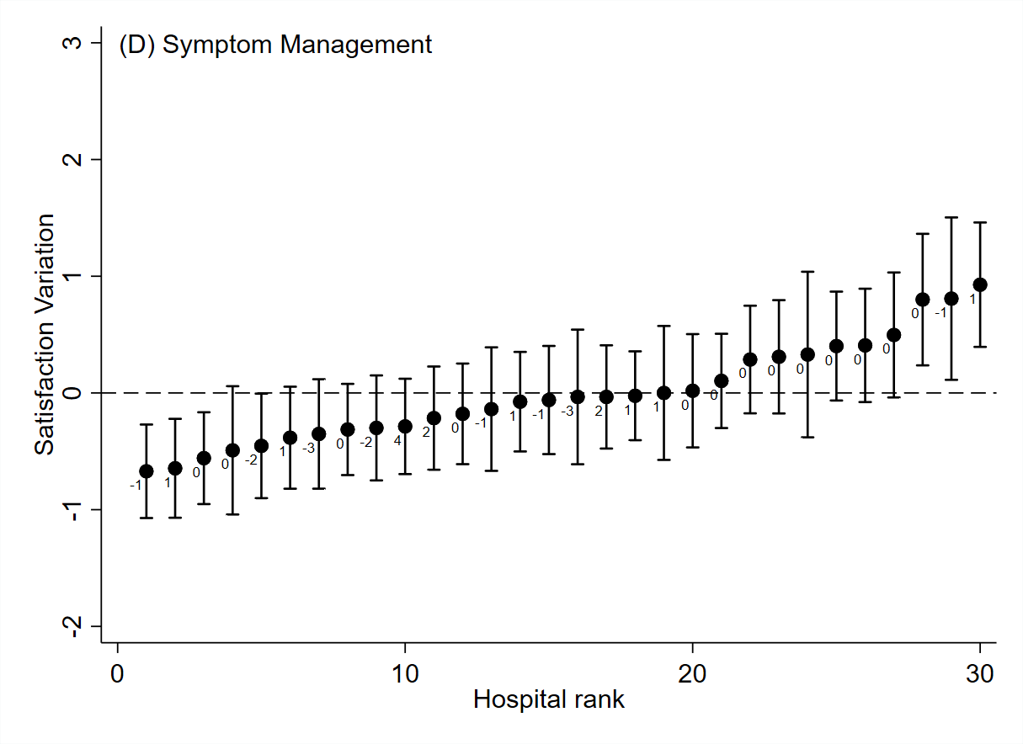
Note: The value label of pot is the hospital rank change after adjustment. The change range of hospital rank is [-3,4].
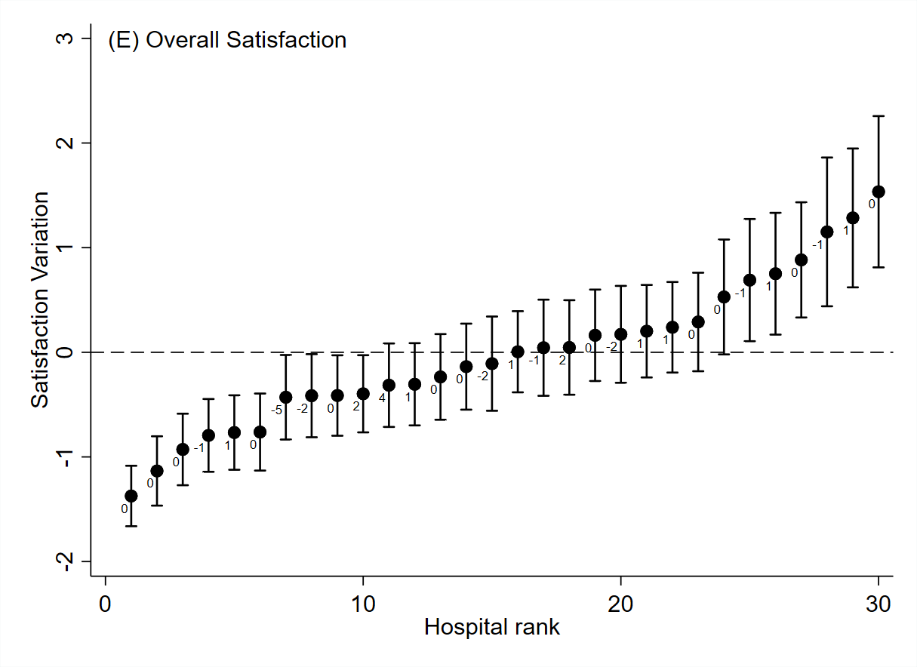
Note: The value label of pot is the hospital rank change after adjustment. The change range of hospital rank is [-5,4].

